Overuse of anonymous function

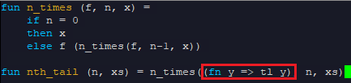

We can just use “tl” because it is already a function!

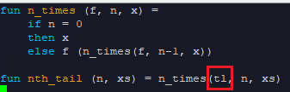

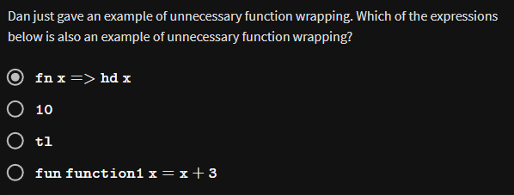



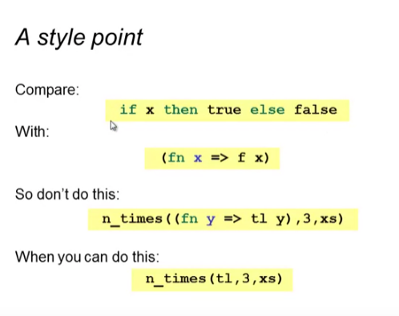

More example of unnecessary:





More okay:



* Binding the function to a variable/constant
* “Callback” function